Central African Republic

## Population Data

The data set shows the political stability estimate of the country each year.

## # A tibble: 23 x 5  
## country iso3c date population popCategory5  
## <chr> <chr> <dbl> <dbl> <chr>   
## 1 Central African Republic CAF 1996 3308233 very small   
## 2 Central African Republic CAF 1997 3392436 very small   
## 3 Central African Republic CAF 1998 3475492 very small   
## 4 Central African Republic CAF 1999 3558014 very small   
## 5 Central African Republic CAF 2000 3640427 very small   
## 6 Central African Republic CAF 2001 3722018 very small   
## 7 Central African Republic CAF 2002 3802128 very small   
## 8 Central African Republic CAF 2003 3881181 very small   
## 9 Central African Republic CAF 2004 3959875 very small   
## 10 Central African Republic CAF 2005 4038382 very small   
## 11 Central African Republic CAF 2006 4118069 very small   
## 12 Central African Republic CAF 2007 4198010 very small   
## 13 Central African Republic CAF 2008 4273366 very small   
## 14 Central African Republic CAF 2009 4337625 very small   
## 15 Central African Republic CAF 2010 4386768 very small   
## 16 Central African Republic CAF 2011 4418636 very small   
## 17 Central African Republic CAF 2012 4436415 very small   
## 18 Central African Republic CAF 2013 4447942 very small   
## 19 Central African Republic CAF 2014 4464175 very small   
## 20 Central African Republic CAF 2015 4493170 very small   
## 21 Central African Republic CAF 2016 4537687 very small   
## 22 Central African Republic CAF 2017 4596028 very small   
## 23 Central African Republic CAF 2018 4666377 very small

## # A tibble: 23 x 5  
## country iso3c date popGrowth popGrowthCat5   
## <chr> <chr> <dbl> <dbl> <chr>   
## 1 Central African Republic CAF 1996 2.62 high growth rate   
## 2 Central African Republic CAF 1997 2.51 high growth rate   
## 3 Central African Republic CAF 1998 2.42 moderate growth rate  
## 4 Central African Republic CAF 1999 2.35 moderate growth rate  
## 5 Central African Republic CAF 2000 2.29 moderate growth rate  
## 6 Central African Republic CAF 2001 2.22 moderate growth rate  
## 7 Central African Republic CAF 2002 2.13 moderate growth rate  
## 8 Central African Republic CAF 2003 2.06 moderate growth rate  
## 9 Central African Republic CAF 2004 2.01 moderate growth rate  
## 10 Central African Republic CAF 2005 1.96 moderate growth rate  
## 11 Central African Republic CAF 2006 1.95 moderate growth rate  
## 12 Central African Republic CAF 2007 1.92 moderate growth rate  
## 13 Central African Republic CAF 2008 1.78 moderate growth rate  
## 14 Central African Republic CAF 2009 1.49 slow growth rate   
## 15 Central African Republic CAF 2010 1.13 slow growth rate   
## 16 Central African Republic CAF 2011 0.724 slow growth rate   
## 17 Central African Republic CAF 2012 0.402 slow growth rate   
## 18 Central African Republic CAF 2013 0.259 slow growth rate   
## 19 Central African Republic CAF 2014 0.364 slow growth rate   
## 20 Central African Republic CAF 2015 0.647 slow growth rate   
## 21 Central African Republic CAF 2016 0.986 slow growth rate   
## 22 Central African Republic CAF 2017 1.28 slow growth rate   
## 23 Central African Republic CAF 2018 1.52 moderate growth rate

## Population trend

The plot shows the population trend of the country.

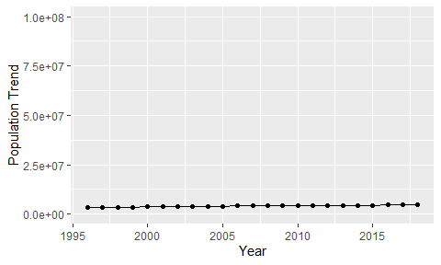

Political Stability Trend

# Population growth graph

The plot shows the population growth rate trend of the country.

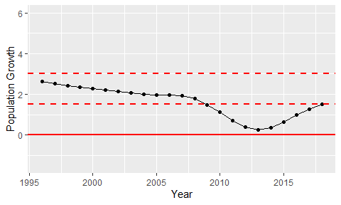

Population Growth Trend